Samuel Sisay

CTEC 298 Final research Paper

Date 03/11/2022

**Introduction**

The most significant components of the CTE 298 Big Data course are covered in this lesson. Learning Big Data might be your greatest investment, providing you with skills that you will need not just in the field of big data, but also in your everyday life. Even if you don't want to work in Big Data, this course will teach you statistics and problem-solving abilities that will be beneficial and practical to you. The Jupyter Notebook is a basic, open-source web application that allows data scientists to create and share documents that include code, equations, computational output, visualizations, and other multimedia features, as well as explanatory text. Information extraction and transformation, numerical simulation, exploratory data analysis, data visualization, statistical modeling, machine learning, deep learning, and other data science tasks may all be done with Jupyter notebooks.

**Summaries**

In this paper, I will detail and clarify the deliverables that were presented and assembled in CTEC 298 and bring to CTEC128 data file and use it in jupyter notebook and executing each file. The deliverables include information and insight on the introductory jupyter notebook that my professor (Dr. Jesse Bemley) assigned to me in the week two folder, the data and how it was put together during this semester, an overview of the CTEC 128 material that was submitted in CTEC 298, and finally, the plot deliverable. Understand the principles of Python programming. Learn the principles of data science, how to use Jupyter Notebook, and how to put together a collection project.

We have been using jupyter notebook platform for our CTEC 298 class. During the half semester we have been practicing on jupyter notebook to data analysis, visualize, extract and transformation numerical simulation. Anaconda Navigator once the installation is complete. It is the GUI used to install applications and packages for the anaconda environment. You will notice that both Jupyter Notebook and JupyterLab are available in the application section of Anaconda Navigator.

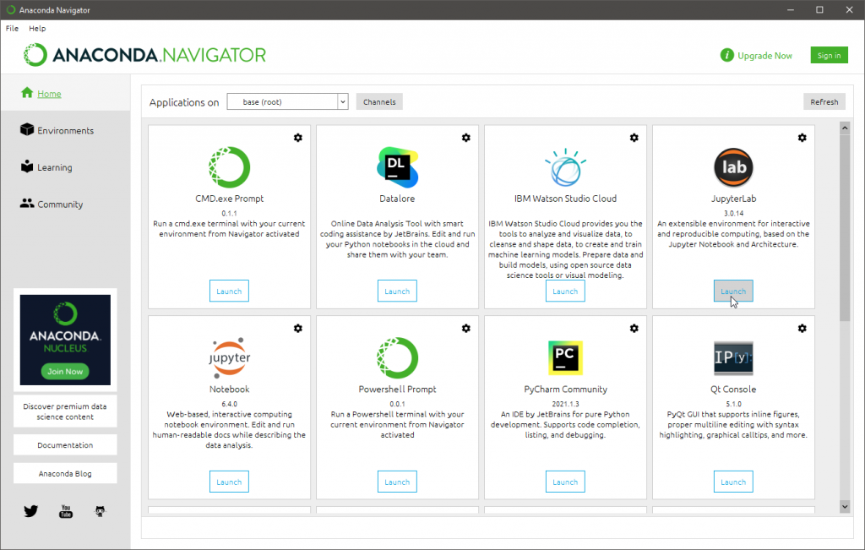

**Using Jupyterm notebook platform**: The popularity of Jupyter notebook goes beyond its use as a stand-alone tool, it’s also integrated with several platforms familiar to data scientists. Before we run the any code on jupyter notebook, we need to download anacoda navigator. It is commen to use to a run a code “Hello World “ program on jupyter notebook liybrary. Imports in Python are important for structuring your code effectively. Using imports properly will make you more productive, allowing you to reuse code while keeping your projects maintainable. Therefore, once we run “Hello World “ the out put shows hello world as the above. Now, for the next step is we have to transform the dataset file to jubyter notebook library.

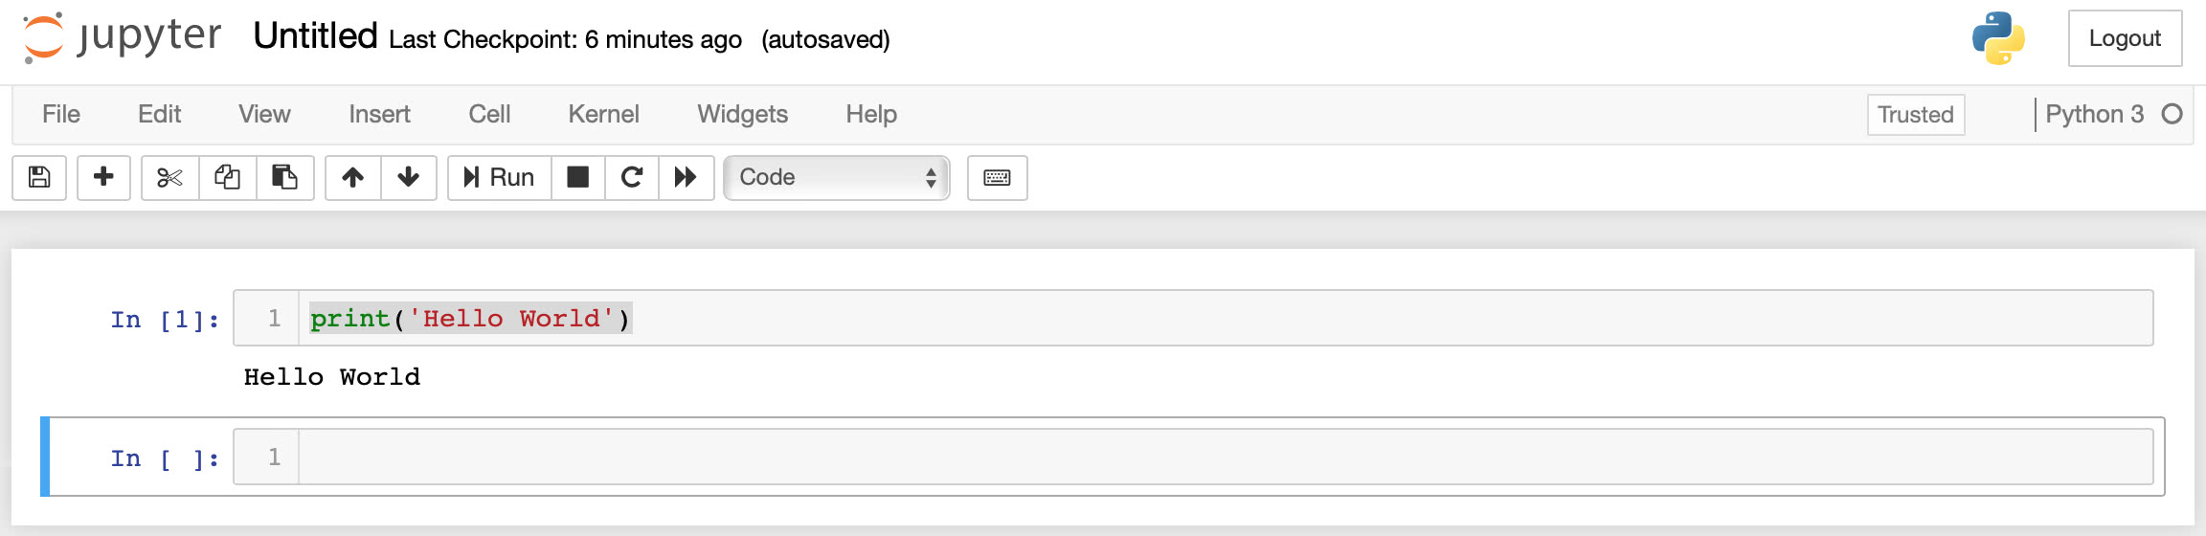 The following figure is the first steps of uploading data file on jupyter nottbook. For example, during this semester I have uploaded quit a few data file on this application inorder to extract my file on jupyter notebook, and to plot different chart for instance histogram chart, pie chart, bar chart, scatter plot chart etc. Once we download the anaconda then we’re going to see how to run and save notebooks, familiarize ourselves with their structure, and understand the interface. We’ll become intimate with some core terminology that will steer you towards a practical understanding of how to use Jupyter notebooks by yourself and set us up for the next section, which steps through an example data analysis and brings everything we learn here to life. Figure 1 illustrates that the CTEC 128 data file has been saved as a csv file in a Jupyter notebook.

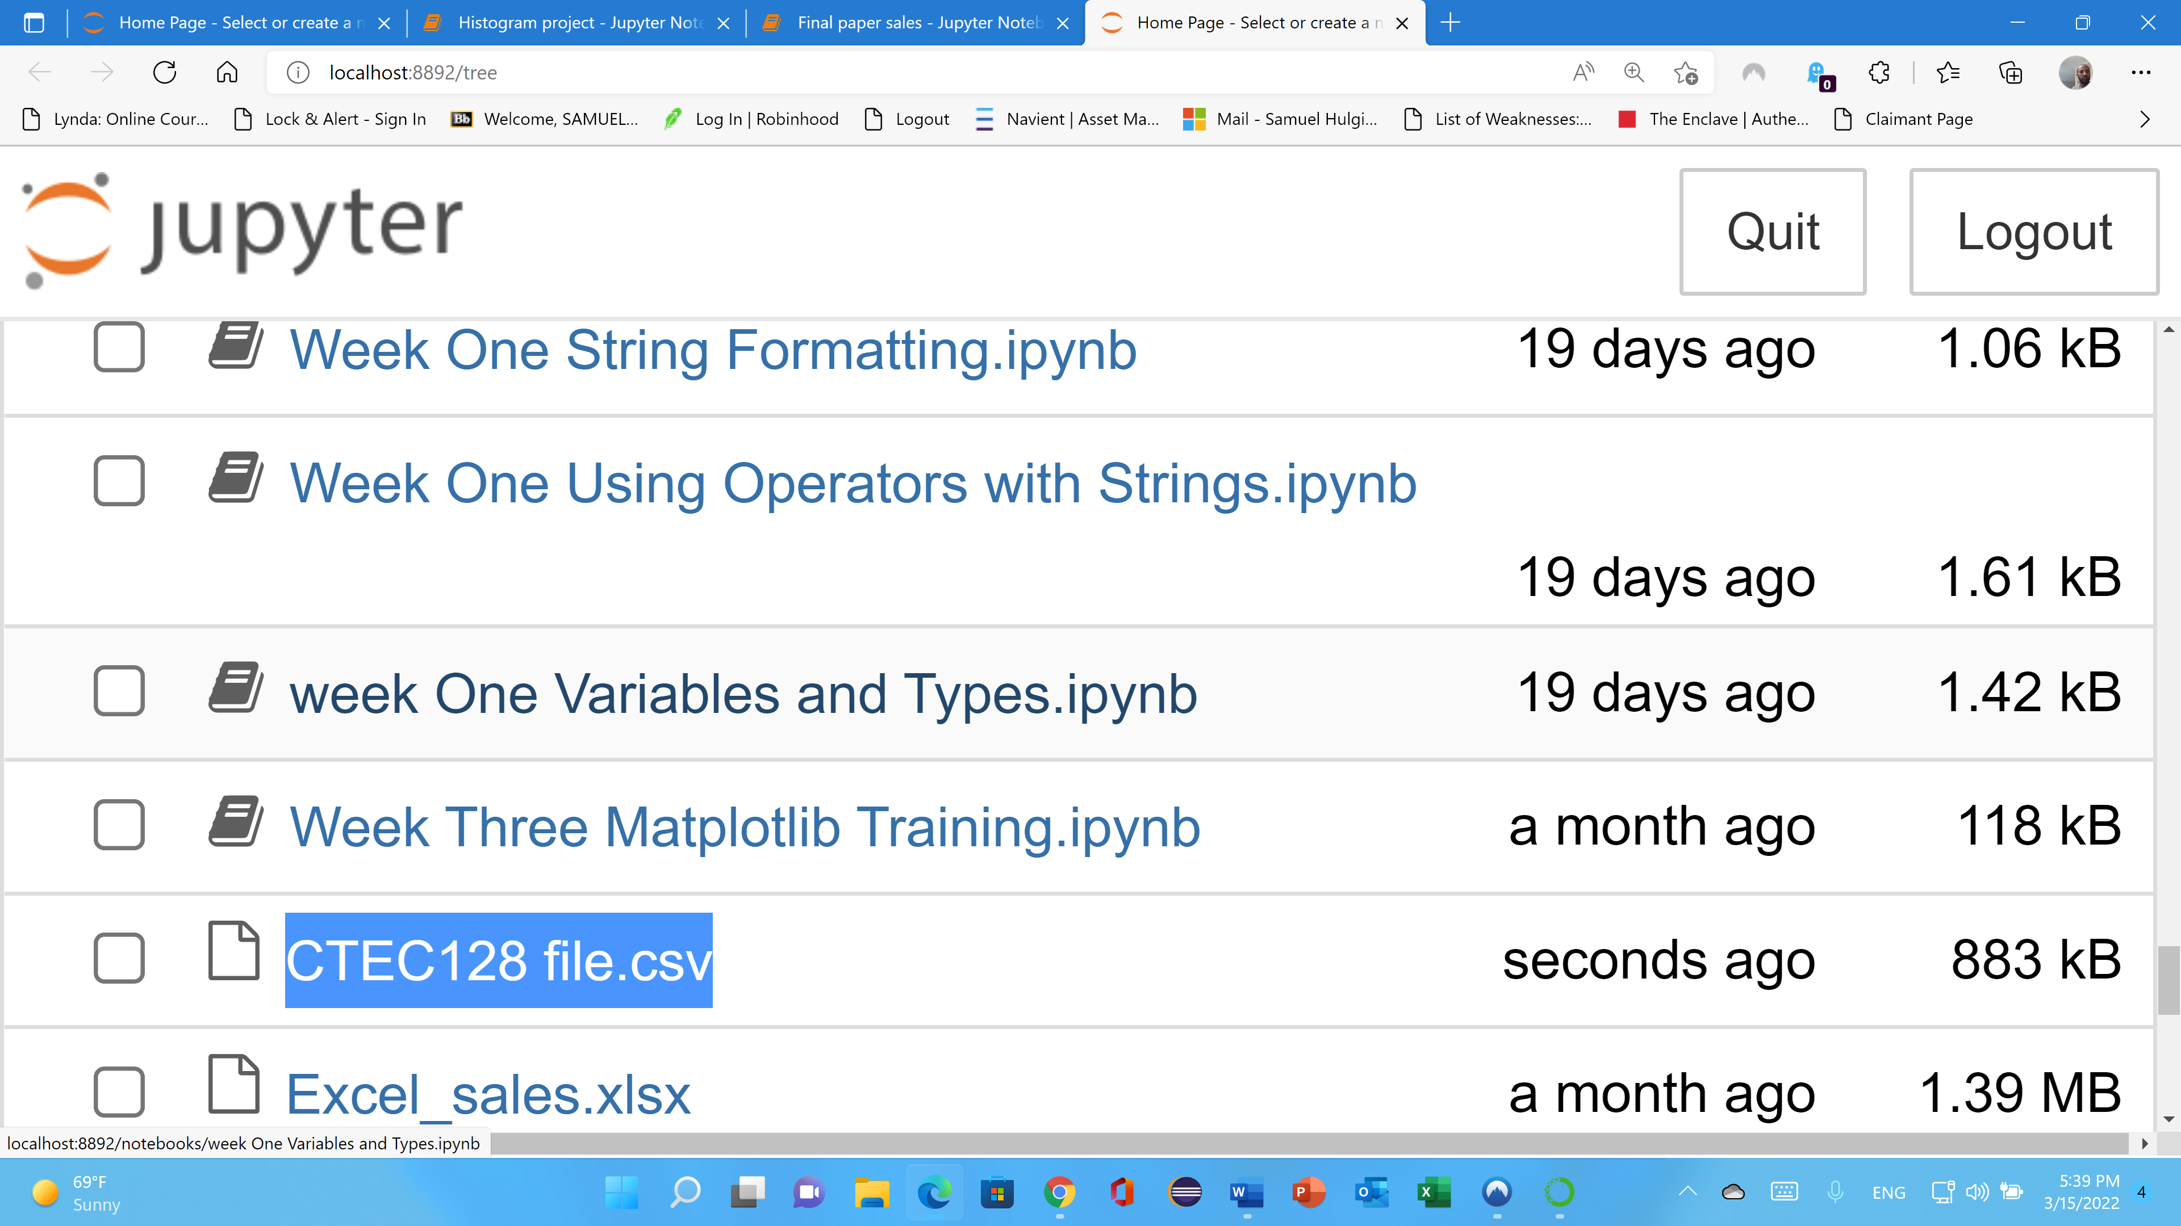

Figure

On figure two shows that the CTEC 128 data file has been extracted or executed the file. Its show that the file extracted data file from the jupyter notebook, you can check as *df* and when you run it will show the first five rows and the last five rows.

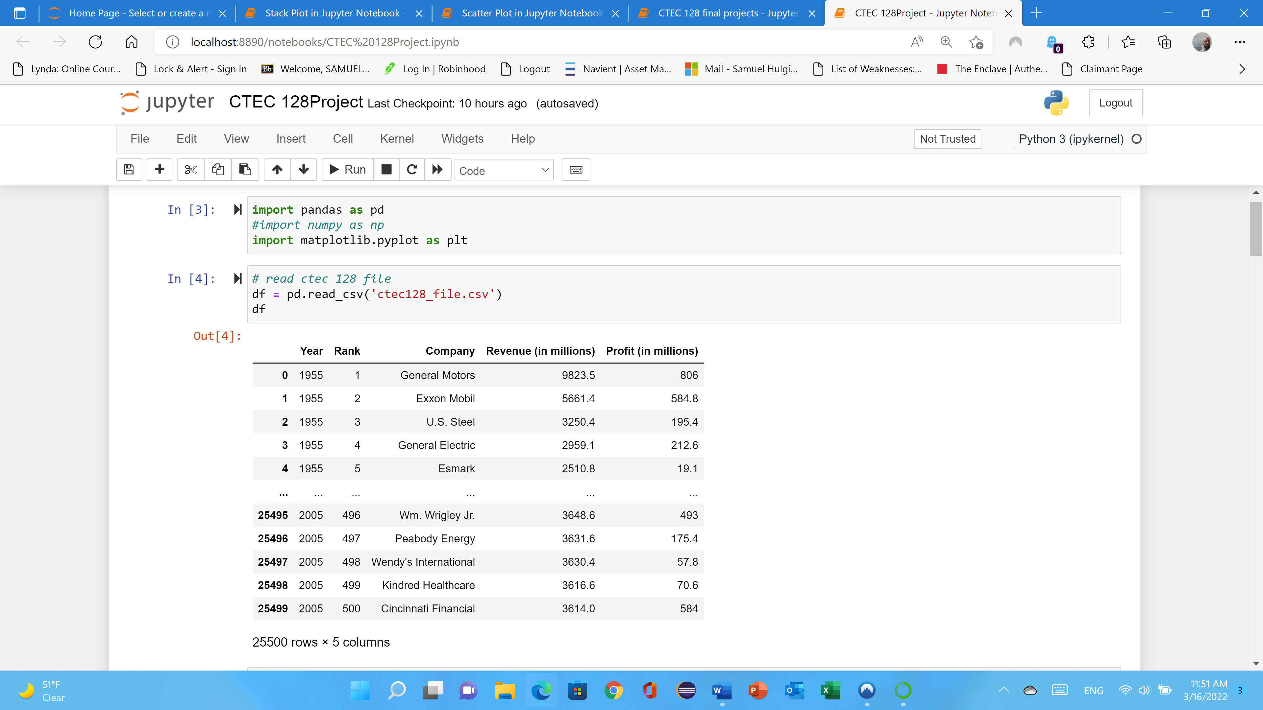

Figure 2.

Figure three shows that the file contains a large amount of data on jupyter notebook therefore it will not extract all of it unless you specify df.head () and df. tail (), in which case the jupyter notebook will extract five data file headings by default. If you want to extract more than five files, you can specify data or any value in the parameter. You may insert a value between the parenthesis to change the number of rows returned

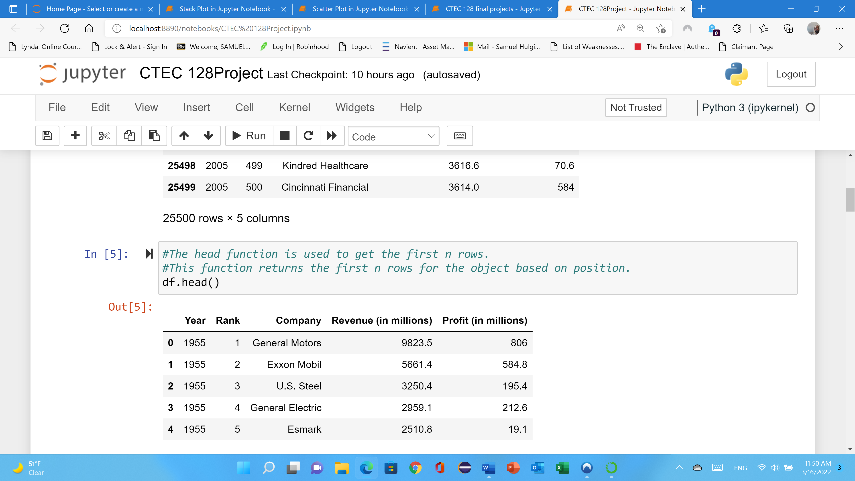

Figure 3

Figure four shows that the file contains a large amount of data on jupyter notebook therefore it will not extract all of it unless you specify df.head () and df. tail (), in which case the jupyter notebook will extract five data file if you use as df.tail() by default. If you want to extract more than five files, you can specify data or any value in the parameter. If you want to extract ten or more data file you may use df.tail(10) or df.head(10) in a Jupyter notebook.

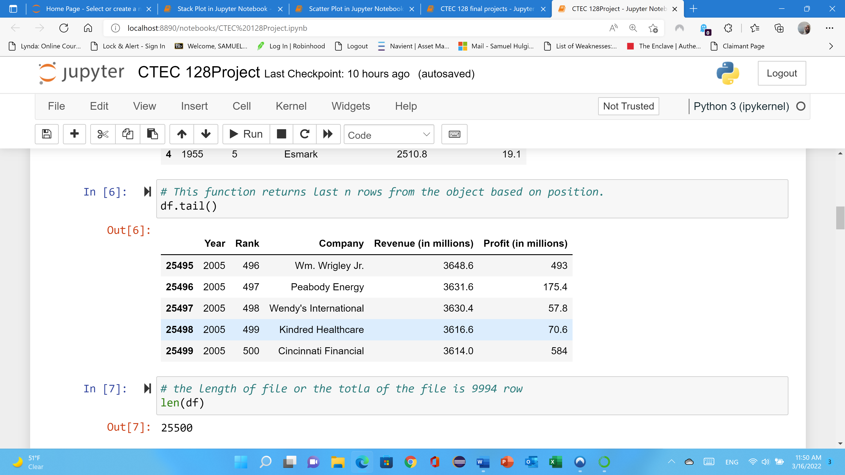

Figure 4

As you can see figure five the CTEC 128 data file extracts or transform a data set into a juypter notebook, it's vital to know the size of the data file. As a result, you can run len(df) in Jupyter notebook to find out the length of the data file. It provides several techniques for identifying both rows and columns, which is "df.shap." The following figure is visualizing each the min, max, std and count for each column for CTEC 128 file.

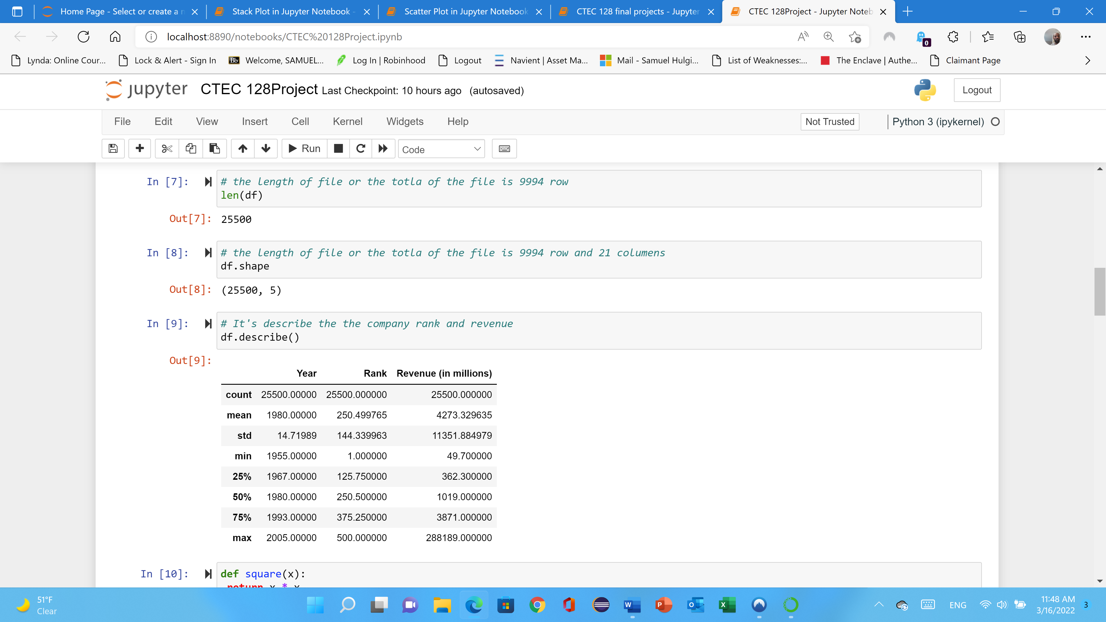

Figure 5

**Pie Chart:** In figure six a Pie chart shows how large each category is in relation to the whole; that is, it uses the relative frequencies form the frequency distribution to divide the pie into different sized wedges. It can only be used to display qualitative data. Therefore, during this project, I have used CTEC 128 data file to explain in Pie chart five different companies’ revenue and profit in 1955. Here is the following the code and pie chart.

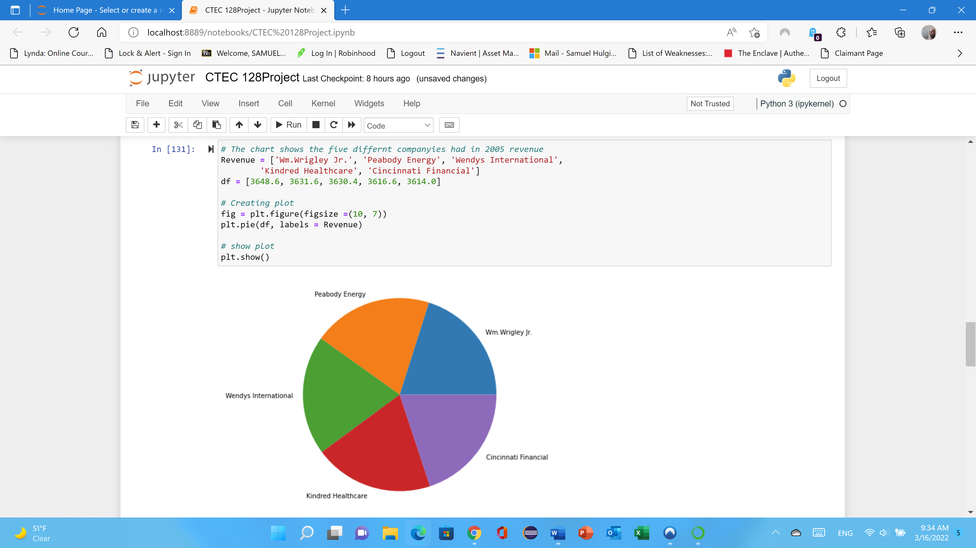

Figure 6

**Scatter Plot**: The primary purpose of a scatter plot is to show the relationship between two variables. The marked dots show both the value of the data point and the overall pattern found on the data. The following figure (scatter) shows that each company ranks, and their profit extracted from CTEC 128 data file.

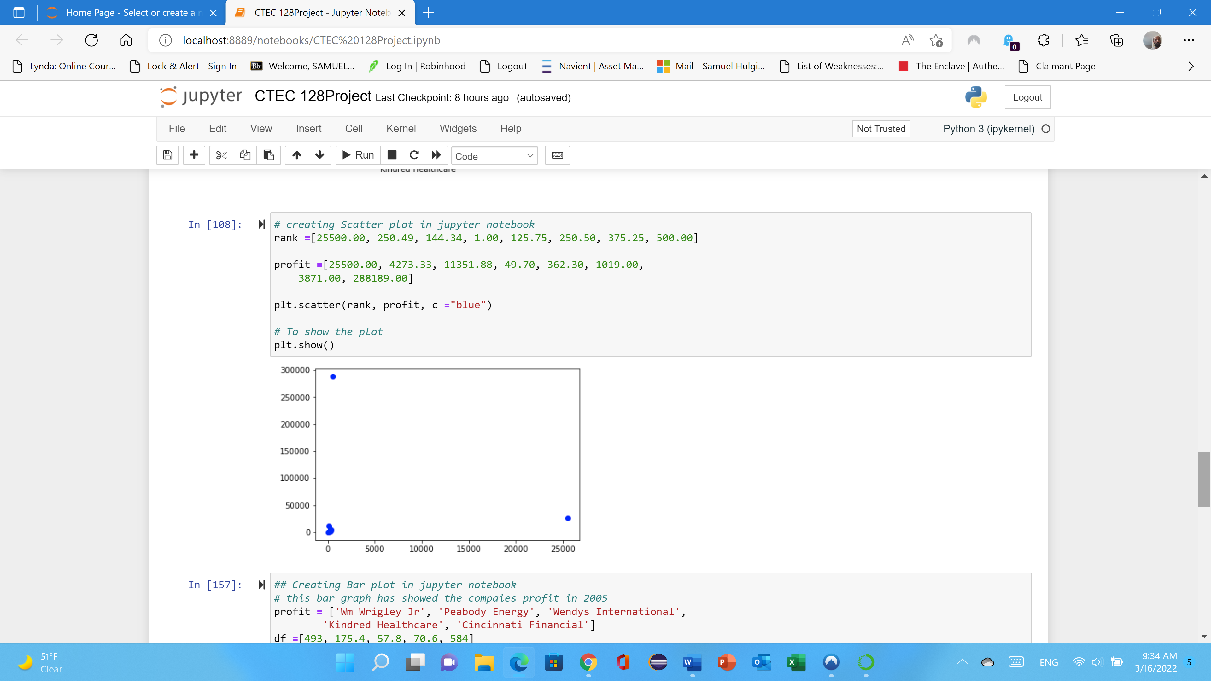

Figure 7

**Bar Graph**: In a bar graph, bars are used to represent the amount of data in each category; one axis displays the categories of qualitative data, and the other axis displays the frequencies. Bar graphs are used to compare things between different groups or to track changes over time. However, when trying to measure change over time, bar graphs are best when the changes are larger.

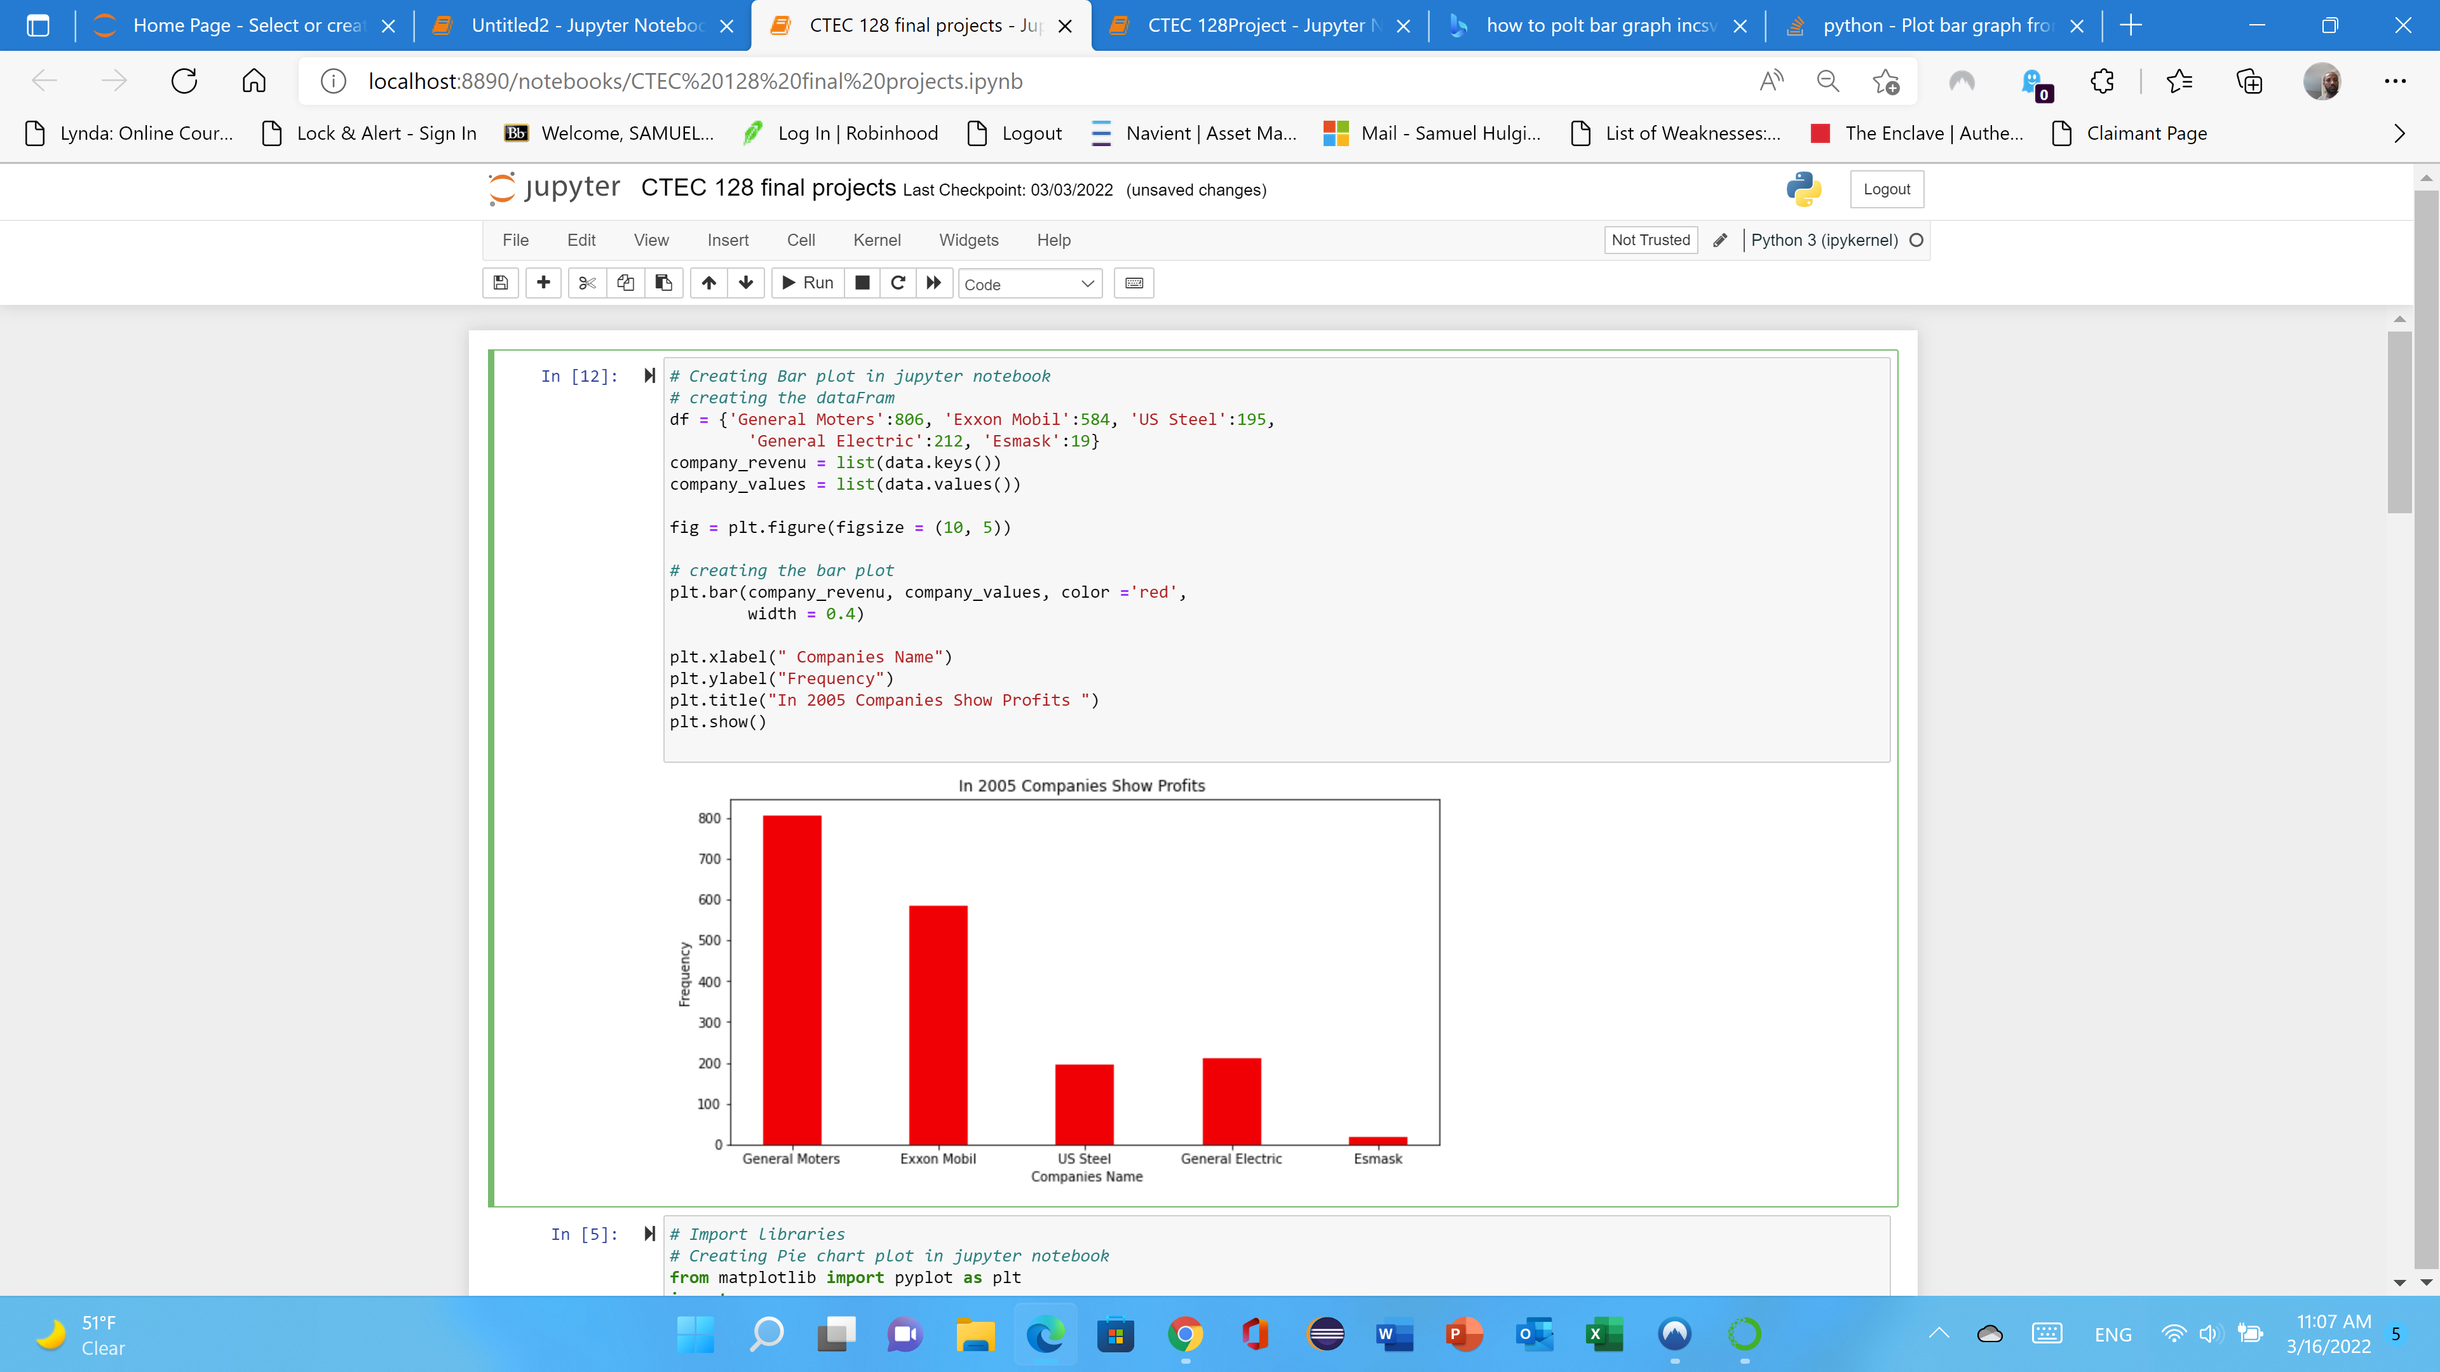

Figure 8

**Stack plot:** A line graph uses straight lines to connect points plotted at the value of each measurement above the time it was taken. The profit shows that from 57.8 to 806 scale that shows blue colors. The company revenues shows that green color which is the revenue shows that more than two thousand five hundred dollars. The company profit shows according to the stack chart is under twenty dollars which is showing that red color for each company is begin with under three thousand. See the graph.

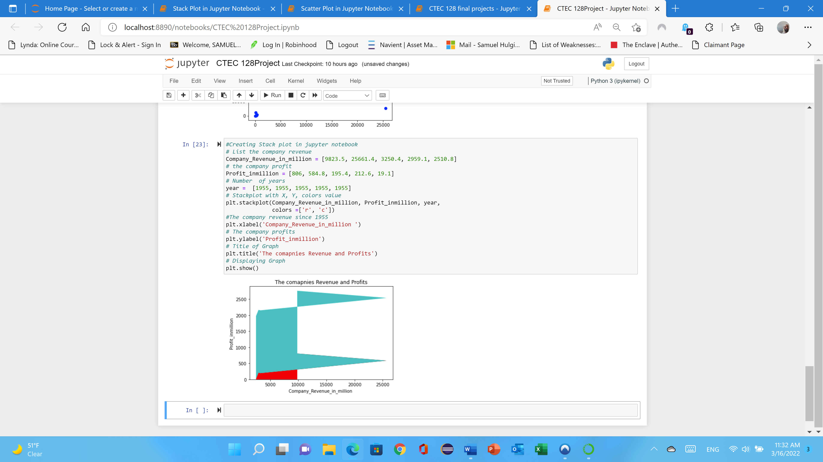

Figure 8

**Histogram:** A Histogram is a bar graph of frequency distribution of quantitative data the horizontal axis is a number line. The graph shows that the company revenue in million and the company profit in million level shows with red and green colors which is showing red is profit level is high and green is also the company’s revenue.

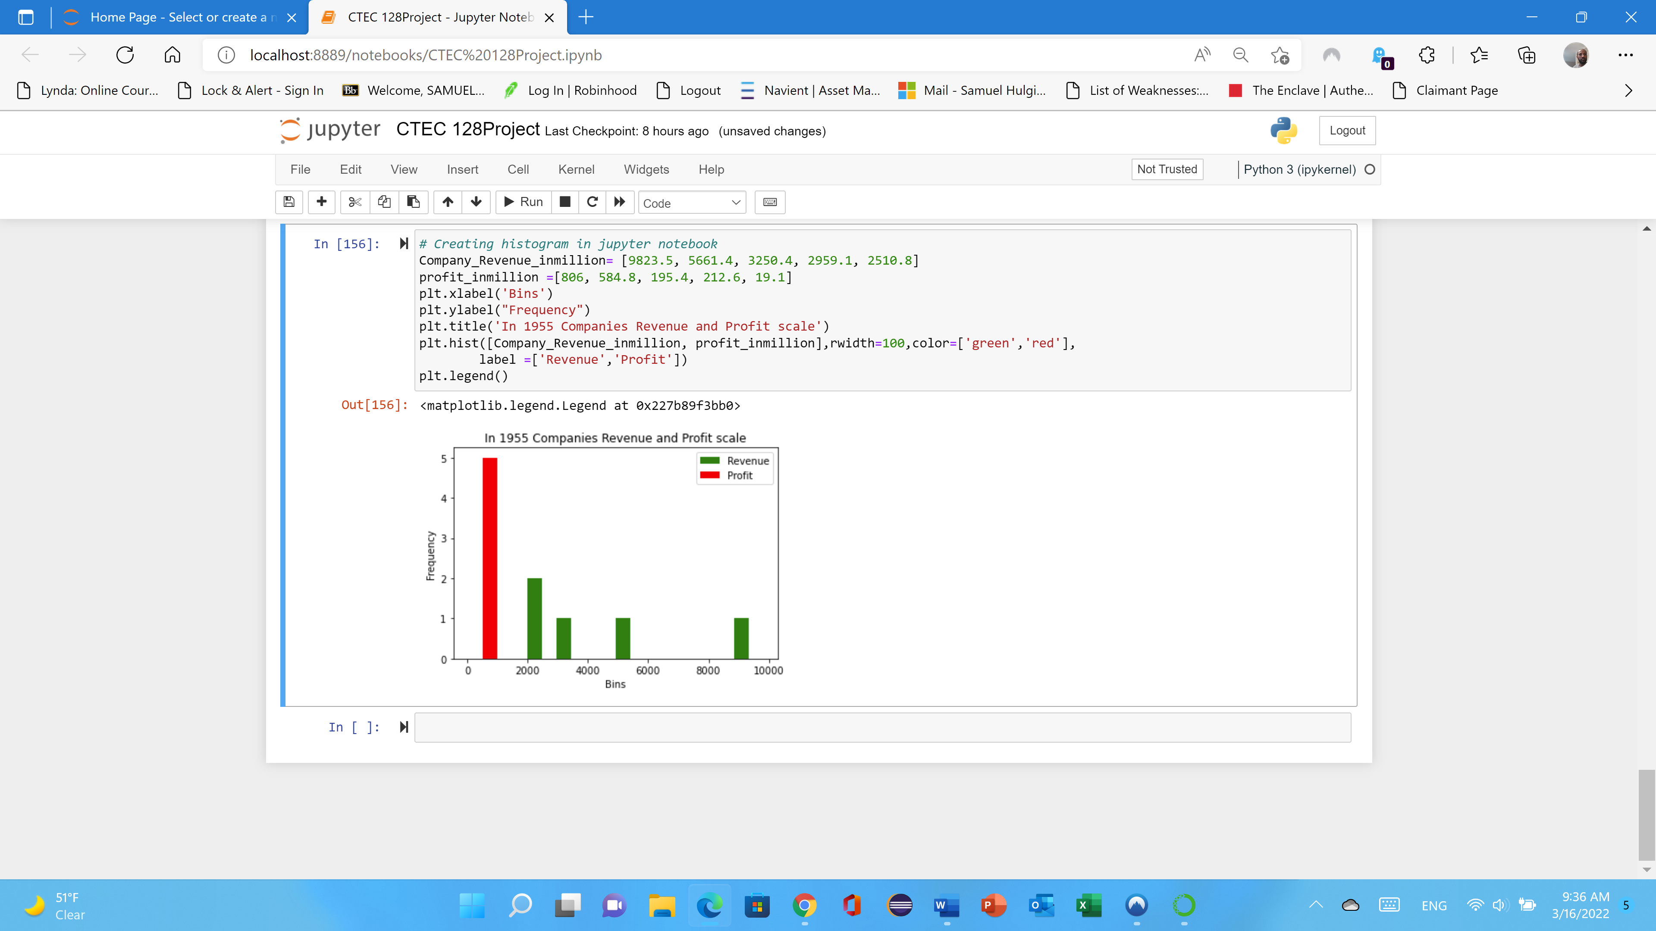

Figure 9

**Multiplot:** Multiplot is often required either for comparing the two curves or show some gradual changes in the multiple plots, and this can be done using subplots. The data file (CTEC 128) creating company revenue in million and profits each year to comparing or visualizing for five year which is 1955. The profit shows that from 57.8 to 806 scale that shows blue colors. The company revenues shows that orange color that the lower revenue for each company is begin with under three thousand. See the graph…

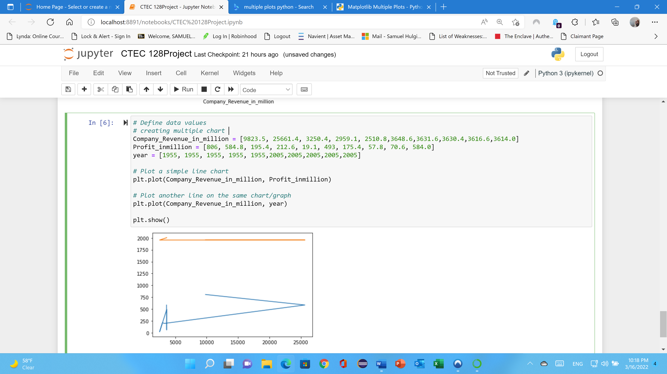

Figure 10

**Tableau:** Tableau is a quick highlight differences between categories, show trends and outliers, and reveal historical highs and lows briefly. Bar charts are simple, yet effective, especially when you have data that can be split into many categories. Visualization helps people to understand things clearly and have a better insight into the topic. Data visualization lets people know where they need to do an adjustment in their business to get a better result. The following graph shows that how the CTEC 128 data file use on Tableau. Once I have downloaded the application, I have uploaded the data and comparing or visualizing each companies profit and revenue as well as rank since 1955 to 2005. I have two screenshots to identify each company profits and revenue.

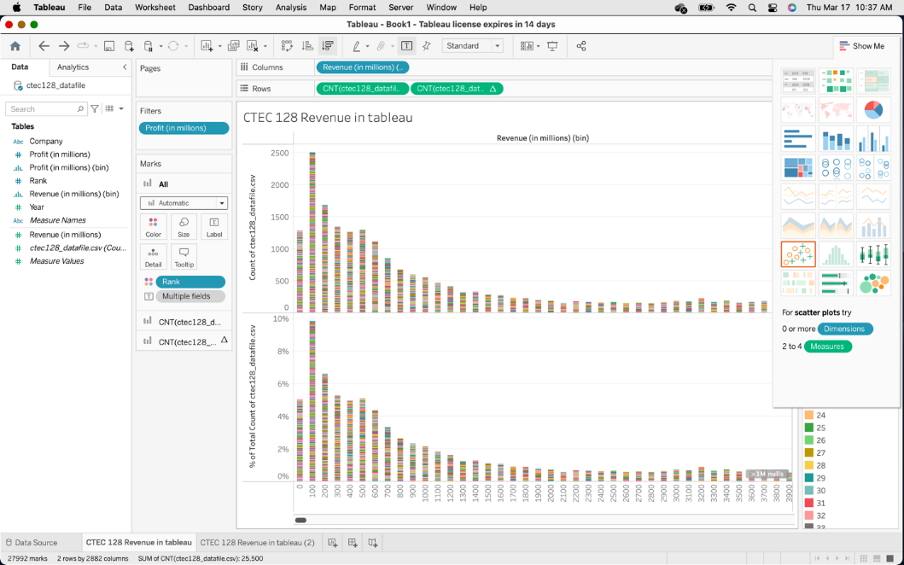

Figure 11

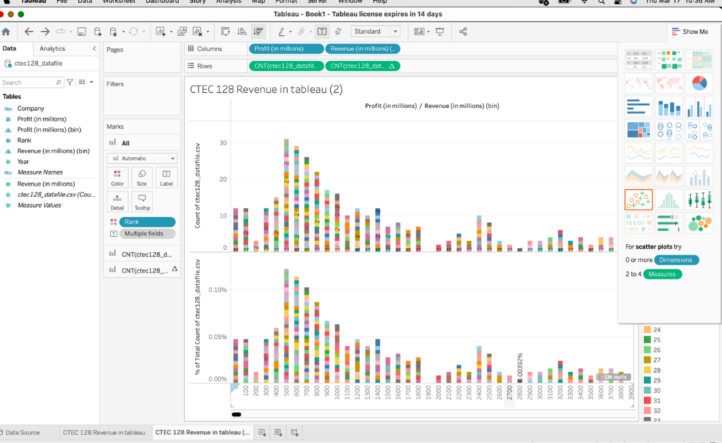

Figure 12

**GitHub:** Throughout the semester, we used jupyter notebook to visualize CTEC 128 and CTEC 298 data files using various charts, and we uploaded each file to GitHub, Google Drive, and Jupyter notebook to share it with other people. We then uploaded the code to GitHub and created repositories with descriptions to describe what was happening and what the code would do if run. The plot deliverables are plots that were created in a jupyter notebook and then ran as python code to display the findings and were plots that our professor assigned to us in CTEC 298 and CTEC 128. The following image is a screenshot from my GitHub account, which contains all the programming I learned in CTEC 298 week one, from part one to part three, and which I uploaded to my GitHub account

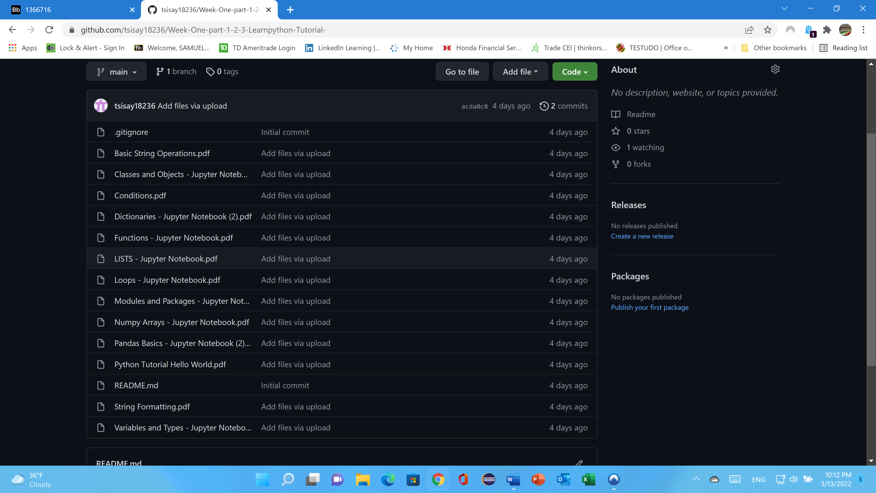

Figure 13

**Google Drive**: This final project and power point sharing with my professor (Dr. Jesse Bemley). I have submitted all my document throughout this semester with him. Because the main reason is he will see it what I have done and will correcting me and will give me feedback. This final project will upload on google drive and GitHub account. The mean reason I have explain the above and the benefit of sharing my file on google drive is the following. Google Drive has plenty of advantages, such as easier file sharing and having a remote location to back up your files. Google Drive's popularity is built on useful collaborative tools and built-in integrations with Google's suite of products and services. Drive to upload and access files on any device, to all the tools that make collaboration with others a breeze. Sharing files: Files are private until you share them. But at any time, you can invite others to view edit or download files and documents. Accessing files from anywhere: Files can be accessed from any smartphone, tablet, or computer. Offline access is also available.

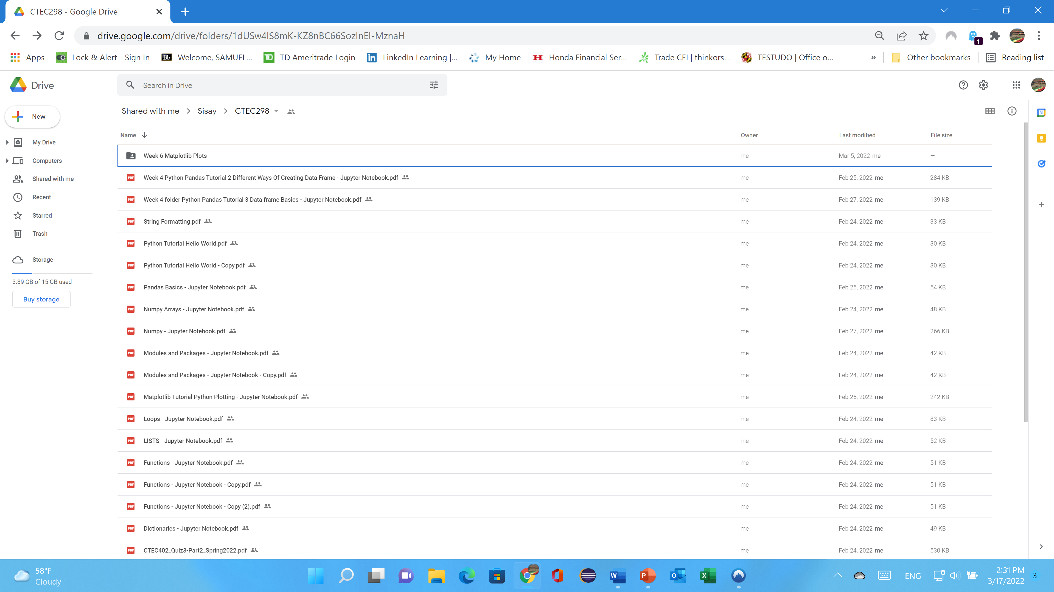

**Summary**

Making data-driven judgments is one of Big Data's primary capabilities. The process of making judgments based on data analysis rather than intuition is known as data-driven decision making. Rather of making decisions based on previous experiences, the choice is made based on probable future patterns. It is now possible to predict which products and services will be successful in the marketplace, demonstrating the value of being first to market. Better professional chances are emerging in datasets all over the universe, and big data analytics is in high demand. Data analysts will become increasingly important in the future. As a result, the CTEC 298 class (we) has been working on a variety of projects this semester, including a mountain survival meal for kid’s project, and utilizing jupyter notebook to run code and plot graphs. The concepts and purpose of using Jupyter notebook, understanding of python programming, understanding of basic data science, understanding of use of python libraries such as transform raw data into information by uploading streaming, collecting different types of data such as text file and csv file will be explained.